Wiring Assembly Instructions
562003 Contacts, ITA, Signal, Crimp 10 Amp, 18-14 Awg.
Fig. A. (Contact Sub-Assembly)
Contact Crimp Information Table
Wire Type | Wire Awg. | Strip Length In Inches | Crimp Tool | Hex Die Set/  Positioner | Indicator | Selector No. | Heat-shrink Length X Dia.
Stranded | 18  16  14 | A) 9/32”  A) 9/32”  A) 9/32” | 452200 | 452202 | Blue  Blue  Blue | 5  6  7 | N/A

Pull Test Values  18 Awg 32lbs  16 Awg 39lbs  14 Awg 48lbs | 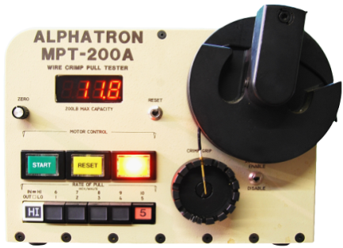
(Values based on M22759/11xx) | (Example of Equipment)

NOTE 1: Refer to IPC/WHMA-A-620B (Class 2) standard (Ch. 11.1) for cable lengths, measurements and tolerance.
NOTE 2: Overall length of cable should be less 3/8” to compensate for the contact attachment.
STEP 1) From the "Contact Crimp Information" Table, use the crimp tool and Positioner set listed.

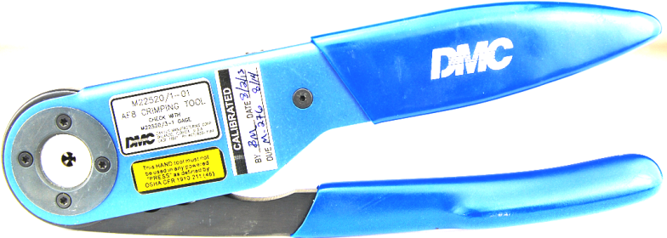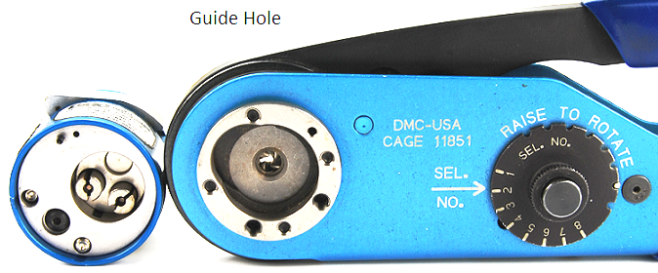
Fig. B. (Crimp Tool 452200) Detail A. (Positioner and Crimp Tool 452202)

STEP 2) Insert the Positioner into the Crimp Tool and tighten in place with the two screws in the Positioner by aligning the guide pin and guide hole in the “Tool Set” as shown in Fig. C. and D. below.

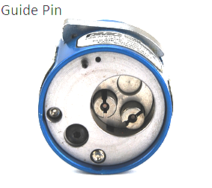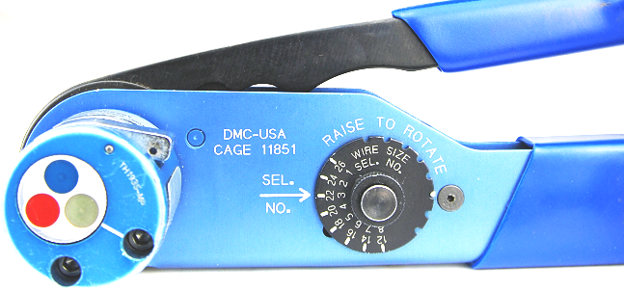
Fig. C. (Positioner) Fig. D. (Positioner inserted into Crimp Tool)

STEP 3) Strip wire to dimensions in “Contact Crimp Information” Table using a ruler/calipers along with a wire stripper as shown in Fig. E.

Fig. E.
STEP 4) Turn the Selector Knob to suit the size of wire to be crimped.
NOTE: Crimp Tool Settings are based on Military Specifications, M22759/11xx Wire Standard. Adjust settings to suit other Specifications.
STEP 5) Align Tangs to slots in Positioner and install contact. Insert Stripped end of wire into Contact and crimp as in Fig. F. and G below.
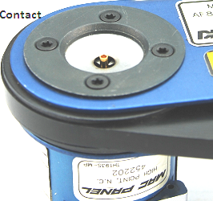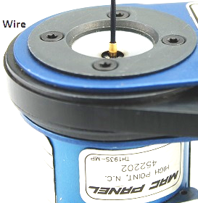
Fig. F (Contact in Positioner) Fig. G (Wire in Contact)
STEP 6) Inspect crimped assembly for extruding strands of wire to prevent shorts and also check for retention by a Pull and Return Test per IPC/WHMA-A-620B (Class 2) standard (Ch. 19.7.2).

